John Gower in Iberia: Six Hundred Years
II International Congress of the John Gower Society
Valladolid, Spain, 18-21 July 2011

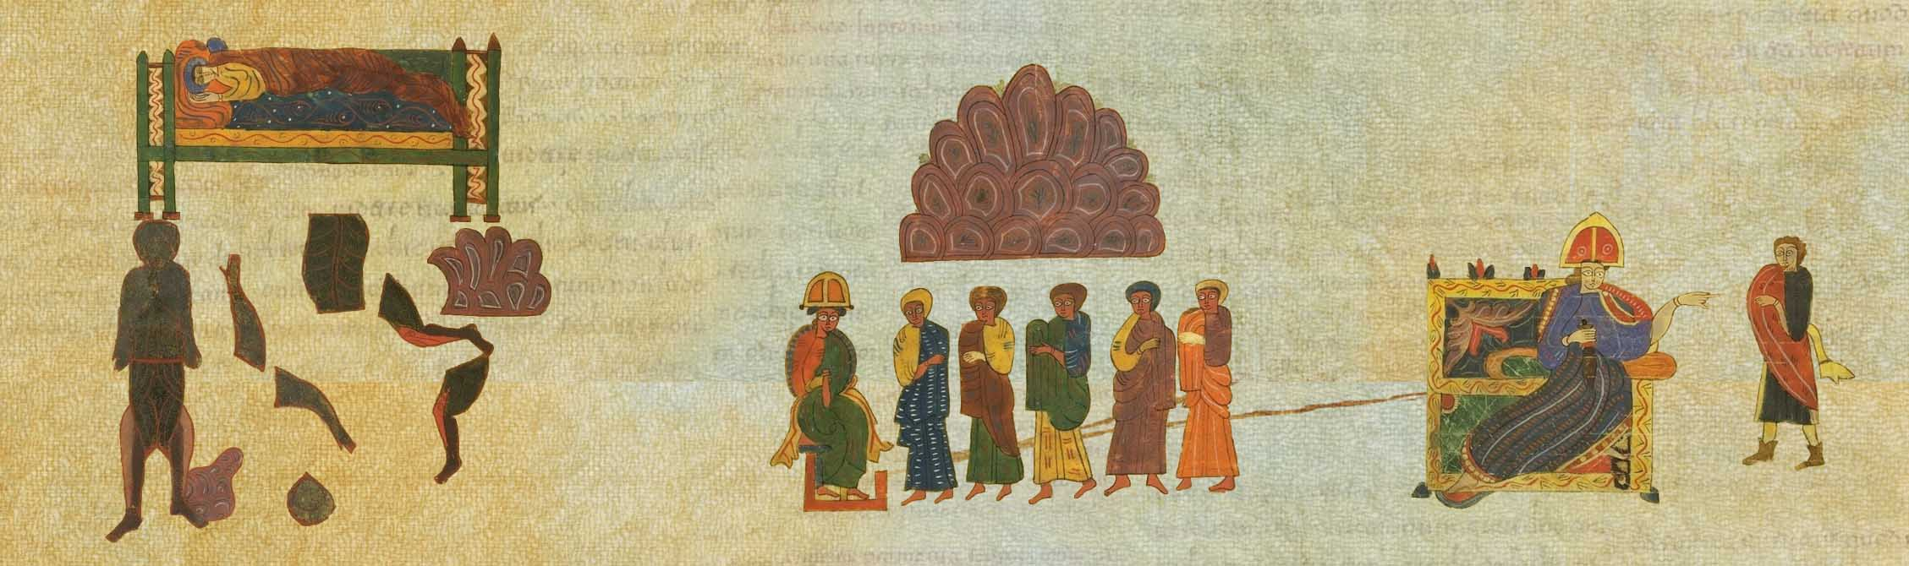
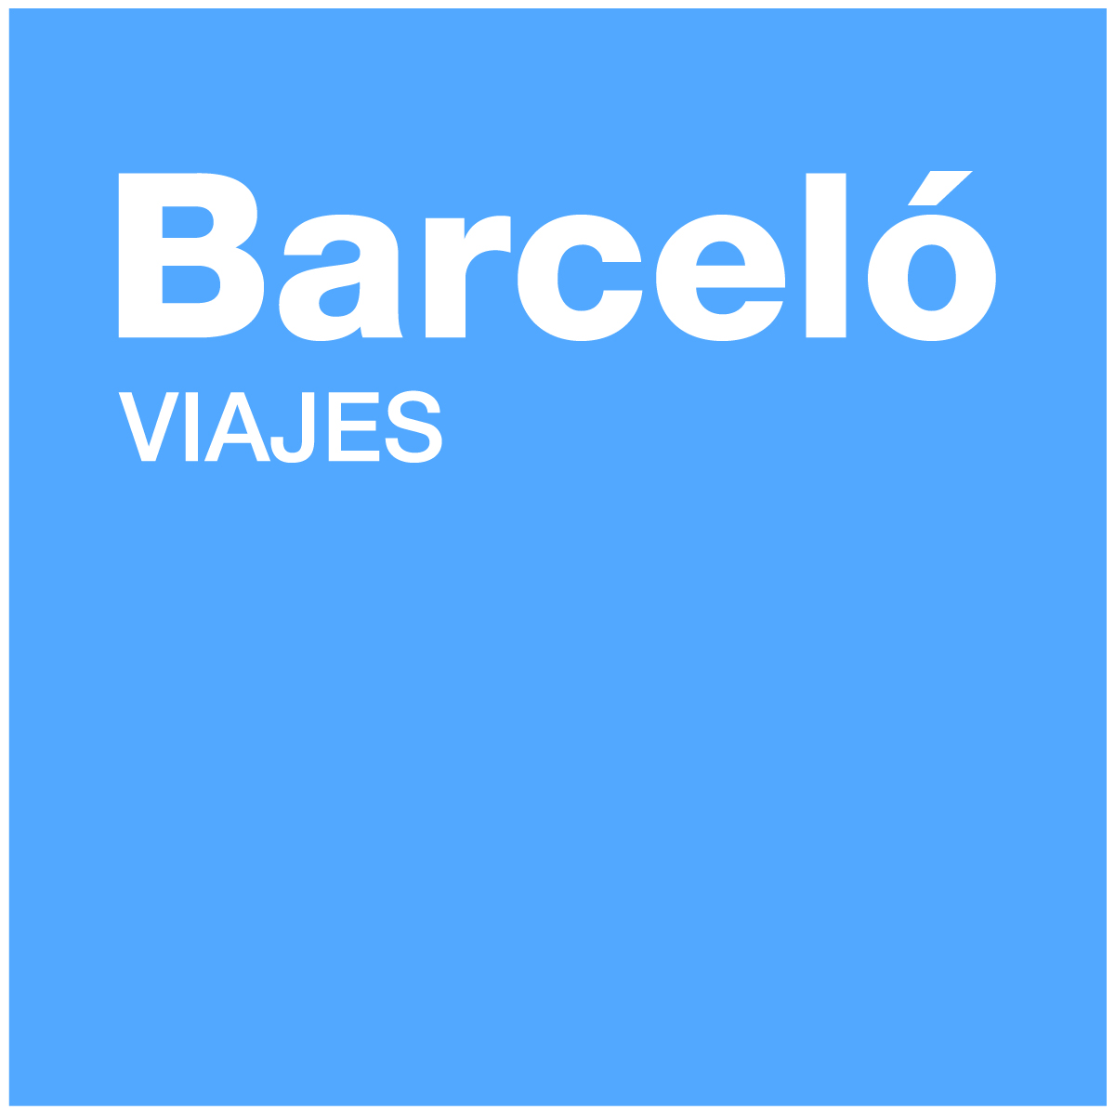

Department of Congresses

Accommodation Form

PERSONAL INFORMATION

Name:.............................................................................................................................................................................

Surname:.........................................................................................................................................................................

Passport number:.…………………………………………........…......................................................................................

Full name of accompanying person in double room:..............................................................................................
Address:................................................................................................................ Postcode:…..............................
City:................................................... Country:.........................................................................

Telephone # :.....…..................... Fax#:................................... E-mail:...................................................................

HOTEL OLID MELIA
SINGLE ROOM 66EUR
DOUBLE ROOM 82EUR

All prices are for a room per night and include breakfast and VAT

HOTEL  N…. |  | Check-in date | ….…………..……… | Double rooms | ………
HOTEL  N…. |  | Check-out date | ……………………… | Single rooms | ………
HOTEL  N…. | ........ ROOM X ....... NIGHTS X ............. €/night |  |  | TOTAL .- | ........... €

PAYMENT METHOD

- Credit Card:

I authorize to charge in my credit card VISA Master Card Amex
the following amount _______________€
Card number: I__I__I__I__I__I__I__I__I__I__I__I__I__I__I__I__I__I__I__I__I
: Expiration Date / /

Name: __________________________________________________________________

Signature:____________________________________________________

- Bank transfer:

I (we) have transferred the amount:_____________________________________

under the name:______________________________________________________________________

Bank: BANCO BILBAO VIZCAYA ARGENTARIA, BBVA
Account number : 0182 6556 16 0201559631
SWIFT: BBVAESMMXXX
IBAN: ES22 0182 6556 1602 0155 9631
NOTES:
The organization has a limited number of rooms booked. In order to make this reservation it is necessary to send this form specifying the payment method.

Important: Once your application is ready, it is necessary to make your payment effective.
- In case you have chosen bank transfer as the payment method, remember to send a copy of the deposit slip together with the application form (via fax or email)
- In case you have chosen the credit card as your payment method, we will charge the whole amount of the reservation to the card number given in the application form.

All applicants will receive an e-mail with the confirmation of their reservation and a booking receipt. Please keep it for your records; remember you will have to produce it at the hotel reception desk when checking in.

By sending this Accommodation form you commit yourself to the total acceptance of the established conditions in case of cancellation.

DEADLINE FOR RESERVATIONS: 15 JUNE 2011

Please, send this form filled up to:

Contact
BELEN ARRANZ
CASA DEL ESTUDIANTE
REAL DE BURAGOS S/N
47011VALLADOLID
Ph. #.: (+34)983264305
Fax #: (+34)902516277
E-mail: JOVLL-UNIVERSIDAD@BARCELOVIAJES.COM

