THE AGE OF GOWER 1408-2008  Conference  12th – 16th July 2008  Conference Booking Form | 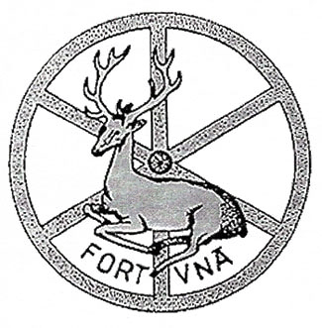

Please complete the booking form and return as soon as possible (contact details below).

Name:

Affiliation:

Address:

Email: |  | Telephone:

Registration
Please check the appropriate box:

Standard fee £125 includes conference registration, tea and coffee, coach travel to Southwark event

Reduced fee (£90 students and unwaged only)

Accommodation
Please check below if you require on-campus accommodation, indicating whether you require a single or double room and which nights you will need. Prices include VAT and breakfast. All rooms are en suite.

 |  | 11th | 12th | 13th | 14th | 15th | 16th | 17th
 | Single Room (£45 per night)
 | Twin Bedded Room (£60 per night)

Southwark Cathedral Dinner (Fork Buffet)
14th July @ £30 per person

 | YES | Number of people:
 | NO

Coach to Swansea
17th July @ £17 per person

 | YES | Number of people:
 | NO

Free Events
The following events are free, but space is limited. Currently, all events are scheduled for the afternoon of Wednesday, July 16. More information and updates will be available at www.johngower.org and in the John Gower Newsletter.

Please number in order of preference (1, 2, or 3).
First come first served.

British Library: special Gower exhibit

Museum of London: guided exhibit

Southwark Walk: guided tour with Martha Carlin

Payment
Please select a method of payment (please note that there is a 2% surcharge for credit card payments. The college does not accept American Express and Diners Cards):

Cheque (please make cheques payable to ‘Queen Mary University of London’)

Visa

MasterCard

Solo/ Switch/ Visa Delta

If paying by credit card please complete the following information.

Cardholder Name
Card Number
Expiry date
Issue Number/Security Code
Valid from Date

Please indicate the total amount here:
A worksheet is attached for your convenience

Total Amount:

Please return this form to: Or email it to:

Beverley Stewart b.stewart@qmul.ac.uk
School of English and Drama
Queen Mary
Mile End Road
London
E1 4NS

If paying by cheque please enclose the cheque with the form, made payable to ‘Queen Mary University of London’. Cheques must be in pounds sterling.

Expenses Worksheet

Event | Cost Per | Times  X | # | Equals  = | Total
Registration | Standard Fee £125  per person | x |  | =
Registration | Reduced Fee £90  per person | x |  | =
Accommodation | Single £45  per night | x |  | =
Accommodation | Twin £60  per night | x |  | =
Southwark Cathedral Dinner/Fork Buffet | £30  per person | x |  | =
Coach to Swansea | £17  per person | x |  | =
 |  | Total =
Please note that there is a 2% surcharge for credit card payments. The college does not accept American Express and Diners Cards

